Press Release 25 January 2021

Tchek raises €3M to accelerate its European expansion for its Artificial Intelligence solutions dedicated to automotive damage detection.

Tchek, a leading European DeepTech startup in car inspection using high-level artificial intelligence, announces a €3 million financing round. The round is led by Demeter, alongside Region Sud Investissement, advised by Turenne Group, and banking players.

Its technological creation, unique on the market, has coded a damage assessment specific to each business by cross-referencing data between Machine Learning (AI), visual recognition and business logic through a precursory decision tree. This inspection system analyses any vehicle photo in order to generate a diagnosis of impacted parts and localized damage, in almost real time and at any time.

This intelligence, specific language, is transverse to all Tchek products and has already convinced more than fifteen major European players in automotive rental, logistics and distribution. Indeed, the recent pandemic has reinforced the need for digitalization and automation from photo taking to claims management, by scan and smartphone according to the chosen support modules.

"Thanks to the entry into the capital of Demeter alongside Région Sud Investissement advised by Turenne Groupe, we are reinforcing the resources given to Tchek to achieve the main objective I have always set myself: to be a leading player in the development of new mobilities. After having recently been adopted by more than fifteen international players, this lifting is further proof of confidence in our ability to continue our development and stimulate the growth of many key global industries in the years to come.»
Anton Fert, CEO - Co-founder Tchek

This fund raising will enable the company to meet the strong demand for its solutions by strengthening its R&D teams and will take advantage of this first round to continue its growth in three vertical sectors:
- Location: With the emergence of "Mobility as a Service" (MaaS) and the massive adoption of car-sharing, mobility operators, users and also insurers are looking for a liability transfer solution adapted to these new uses and Tchek perfectly meets these new expectations. The financing will technologically reinforce its market-approved comparison module, offering a complete suite adapted to all types of agencies.
- Logistics and OEM: Today, more than 5 billion inspections are carried out each year. Before a vehicle is put on the market, it undergoes an average of 11 inspections (factory exit, distribution, etc.). Challenged by regulations, the energy transition, the transformation of uses and technologies (automated factories, connected cars, rental and car-as-a-service, etc.), the automotive sector had been undergoing profound change for several years. Tchek industrializes and automates an expensive journey with a productivity solution that exceeds human capacities through its precision and neutrality.
- The second-hand market: Tchek continues its mission of extending human capacities through damage recognition and 3D vision to enhance the value of a vehicle. The technology will power 100% digital platforms with the launch of its application. Tchek accompanies and automates part of their customer journey: inspection in case of trade-in. A support from taking pictures to assessing the condition of a vehicle, without interference and without contact.

"Tchek addresses the challenge of risk and liability transfer, in the context of shared mobility, not based on ownership. This is a major theme and challenge for Demeter, as a pioneer in investing in sectors related to environmental and ecological transition. Our seed fund Demeter 6 Smart City was the perfect vehicle to support Tchek in this new phase. Tchek's team, led by Anton Fert, Léa Chevry and Sofiane Benabdallah, has already successfully deployed a technology exceeding market expectations and a new form of support. Through its investment, Demeter provides Tchek with the means to accelerate its commercial development and extend its success to other countries. »
Christophe DESRUMAUX - Partner - Demeter

"We are very proud to continue to support Tchek in its development in Europe. We share the same vision of tomorrow's mobility: rented, shared and connected. We are convinced of the complementarity between modes of transport and new forms of mobility. Tchek's strong ambition has been accelerated during the health crisis by the efficiency of digital automation and by the strong value proposition provided. »
Marie DESPORTES, Partner - Turenne Groupe

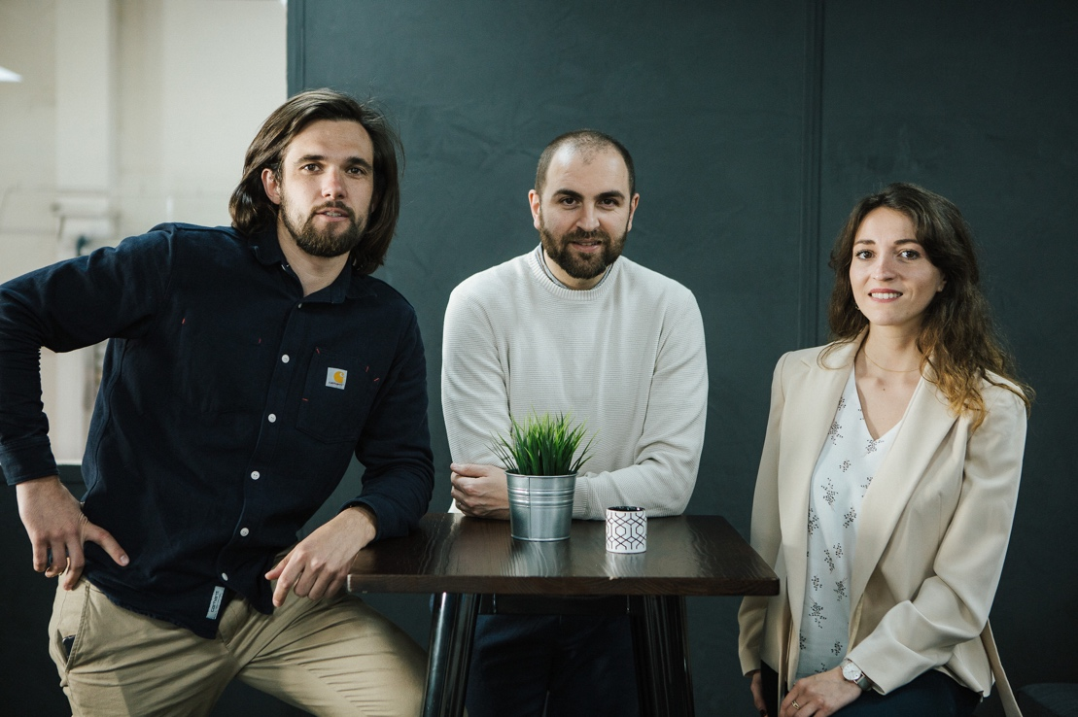

About Tchek
Since 2016, Tchek's mission has been to accompany mobility and the automotive industry to new technological challenges and uses by :
- Offering new AI solutions to create value in their role and experience or to reduce repetitive tasks with no added value;
- Accompanying in the deployment of these new uses by the Tchek Academy
- Raising Group awareness of profound changes "Ready for new mobility".
Tchek offers a range of SAAS products and services (Damage Detection API, automatic estimate of repair costs; Check In/Check Out alerts, Vehicle Identification; 360 picture remarketing). Tchek Scan, the brand's historical product, is the world's first stand-alone scanner that increases productivity by automating and industrialising the inspection of the entire vehicle with great precision, thanks to 3D reconstruction, photo capture and rapid analysis of new repairs to be carried out by Artificial Intelligence. Tchek also won the Innovation Award at CES - Las Vegas in 2020.

About Demeter
Demeter is a major European player in private equity for the energy and ecological transition. Its funds invest from €1M to €30M to support companies in the sector at all stages of their development: innovative start-ups, fast-growing SMEs and ETIs and infrastructure projects. The Demeter team has 37 people based in Paris, Lyon, Grenoble, Metz, Madrid and Münster and manages €1 billion. The team has made 180 investments in 15 years. The Demeter 6 Seed Fund, investor in Tchek, is dedicated to seed financing of innovative technology companies. This €46M fund was raised with the support of the Fonds National d'Amorçage (FNA) managed by Bpifrance Investissement within the framework of the Programme d'Investissement d'Avenir.
Christophe DESRUMAUX - Partner - +33 (0)6 81 44 80 12 - media@demeter-im.com

About Turenne Groupe
Turenne Groupe, one of France's leading private equity firms, has been helping entrepreneurs with their innovation, development and business transfer projects for 20 years, advising Sud Investissement on the management of its investments. An independent player, the group manages more than €1 billion. Its teams of 64 professionals, including 48 investors, based in Paris, Lille (Nord Capital Partenaires), Lyon, Marseille and Metz, support 260 business leaders, particularly in the health, hotel, innovation, BtoB services and digital sectors.
As a committed investor, Turenne Groupe actively supports its portfolio companies in their CSR approach. As a responsible company, it finances and operationally manages the Béatrice Denys Foundation for Therapeutic Innovation, which rewards the most successful projects in French academic medical research aimed at creating a company, and it supports the Banlieue Sans Frontières en Action (BSFA) Association, which aims to improve the living conditions of suburban residents through professional integration.

The fundraising was carried out in collaboration with :
- Company consulting : IODA Consulting - Oriane BURLAT
- Law Firms & Legal Audits : BBLM Avocats - Myriam CUVELLIER
- IP Audit: IPTrust - Emmanuel HUYGHE

